# **CTF Topic: Installing Burp Suite**



# **1. Introduction**

Burp Suite is a comprehensive cybersecurity tool used for testing web application security. It's developed by PortSwigger, and it's widely used by security professionals and penetration testers to assess the security of web applications. Burp Suite provides various tools that can help in finding security vulnerabilities such as SQL injection, cross-site scripting (XSS), and other types of security flaws.



# **2. Tools and requirements**

Windows

# **3. Scenario**

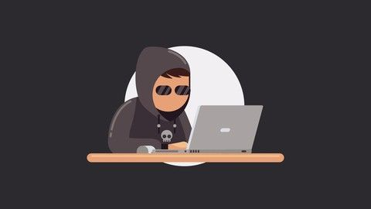

Khundii wants to start a journey as a bug bounty hunter. So his friend suggests he install the burp suite and start scanning for a vulnerability.

# **4. Process to Perform**

# To perform the process go to the link and download the burp suite community edition.

# [**https://portswigger.net/burp/documentation/desktop/getting-started/download-and-install**](https://portswigger.net/burp/documentation/desktop/getting-started/download-and-install)

# 

# **Let's Begin The Challenge**

# **Question**

**Flag 1: Was the installing process successful?**

Answer: No answer needed

Flag Captured.

# **Hint:**

